Student Activity
24 Electrical power

TASK
To investigate the rate at which electrical energy is consumed by an electric motor and the efficiency with which it uses supplied energy.

THEORY
Mechanical power = 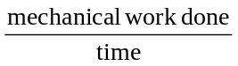
or
P = 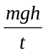
where m = the mass in kilograms being lifted
g = acceleration that a falling object will experience due to gravity (9.8 m s^{–2})
h = height that mass is being lifted in metres
t = time to lift mass in seconds
Efficiency = 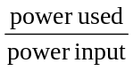 × 100%

EQUIPMENT
• small electric motor with attached pulley
• DC ammeter (0–1 A) or current sensor
• DC voltmeter (0–5 V) or voltage sensor
• power supply
• cotton thread
• metre rule
• mass balance
• stopwatch (not necessary when using electronic measure)
• 3 masses (50 g each)
• mass holder

ICT
Most current sensors have a 1 A range and are suitable for this experiment.
They are generally current-protected, but take care to check the manufacturer’s specifications, and use sensors with care.
Exceeding the maximum current rating will permanently damage an ammeter or sensor.
Sample rate: Sample voltage and current simultaneously at approximately 10 samples/second.
Graph: power (V × I) against time.

NOTES ON METHOD
1. Using the mass balance, accurately measure the mass of the thread, pan and one of the 50 g masses. Record your measurements.

2. Connect the circuit shown in the diagram on the next page.

3. Attach the thread to the pulley. Measure the length of the thread through which the motor will lift the pan, and make sure that the point on the thread to which you measure is clearly marked.

4. Start the motor and simultaneously read the potential difference V across the motor and the current I through it.
You may need several people to perform these tasks using a voltmeter and an ammeter.
Record the values of V and I.

5. Repeat step 4 using increasing numbers of masses, and record all measurements.

24 Electrical power
continued
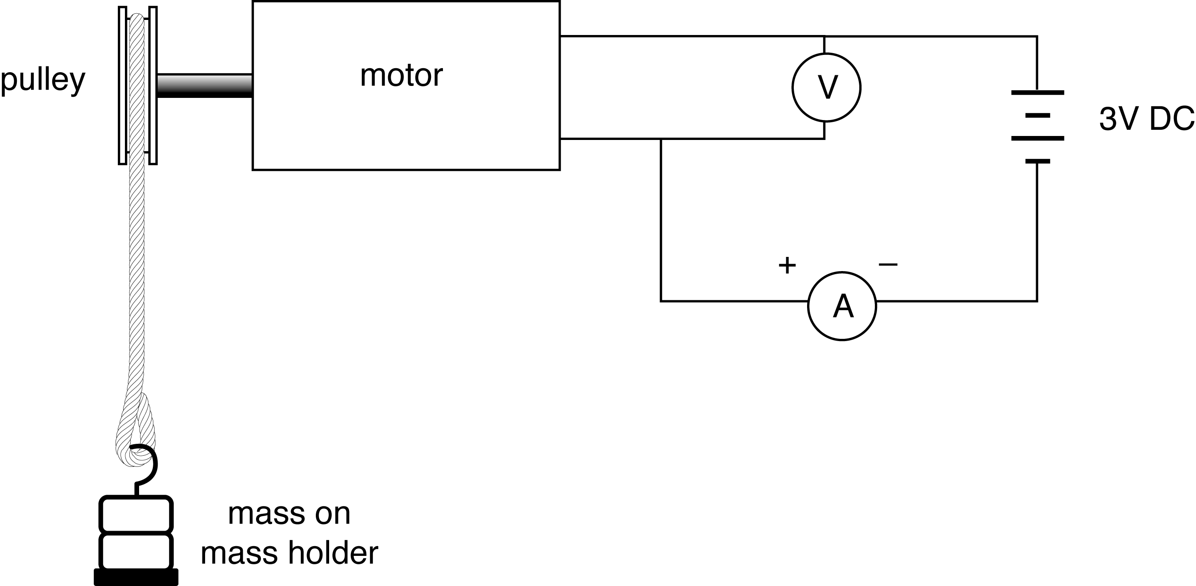

DATA & ANALYSIS
The following data need to be recorded:

Length of thread: m
Mass 1: kg
Mass 2: kg
Mass 3: kg
g: 9.8 m s^{–2}

Average V: volts
Average I: amperes
Time taken: seconds

Calculate power used and power input for each mass and, hence, the efficiency of the motor in lifting each load:
Power used = = watts
Power input = V × I = watts
Efficiency = × 100 %

CONCLUSION
Comment on the efficiency of the motor under the varying loads investigated, and summarise your findings.

QUESTIONS
1. Find the power input to the motor when it is lifting no load.
Measure this by reading V and I when the motor is under no load.
2. Look carefully at the experimental technique described.
Describe any errors that may have affected your results.
Which of these errors may have had the greatest effect on your answers? Explain.

